**Experiment 6**

**Aim:** To study the input and output characteristics of a transistor in its Common Base configurations (CB).

**Theory:**

A bipolar junction transistor, BJT, is a single piece of silicon with two back-to-back P-N junctions’ can be made either as PNP or as NPN. They have three regions and three terminals, emitter, base, and collector represented by E, B, and C respectively. The direction of the arrow indicates the direction of the current in the emitter when the transistor is conducting normally.

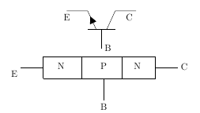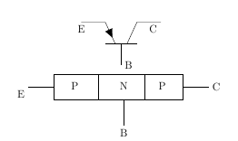

Fig 1: Representation of NPN and PNP transistor respectively

**Emitter** **(E):** It is the region to the left end which supply free charge carriers i.e., electrons in n-p-n or holes in p-n-p transistors. These majority carriers are injected to the middle region i.e. electrons in the p region of n-p-n or holes in the n region of p-n-p transistor. Emitter is a heavily doped region to supply a large number of majority carriers into the base.

**Base** **(B):** It is the middle region where either two p-type layers or two n-type layers are sandwiched. The majority carriers from the emitter region are injected into this region. This region is thin and very lightly doped.

**Collector** **(C):** It is the region to right end where charge carriers are collected. The area of this region is largest compared to emitter and base region. The doping level of this region is intermediate between heavily doped emitter region and lightly doped base region.

In CE configuration, the input current IB and the output current IC are related by the equation shown below.

IE=IC+IB

**Operation of Bipolar Junction Transistor:**

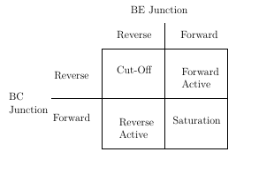

Fig 2: Four Operating Conditions

**Cut-Off Region:** In Cut-Off region both junctions are reverse biased, Base-emitter junction is reverse biased (VBE<0)and also Collector-Base junction is reverse biased(VCB>0).With reverse biasing, all currents are zero.There are some leakage currents associated with reverse biased junctions,but these currents are small and therefore can be neglected.

Application: Open switch

**Forward Active Region:**In Forward Active region Base-emitter junction is forward biased(VBE>0) and Collector-Base junction is reverse biased(VCB>0). In this case, the forward bias of the BE junction will cause the injection of both holes and electrons across the junction. The holes are of little consequence because the doping levels are adjusted to minimize the hole current. The electrons are the carriers of interest. The electrons are injected into the base region where they are called the minority carrier even though they greatly outnumber the holes.

Application:Amplifier in analog circuits

IC=αF×IE+ICO

where,

αF is the forward current transfer ratio

ICO is Collector reverse saturation current

**Saturation Region:**In Saturation region both junctions are Forward biased,Base-emitter junction is forward biased(VBE>0) and also Collector-Base junction is forward biased(VCB<0). Maximum currents flows through the transistor with only a small voltage drop across the collector junction.The transistor also does not respond to any change in emitter current or base-emitter voltage.

Application:Closed switch

**Reverse Active Region:**In Reverse Active region Base-emitter junction is reverse biased(VBE<0) and Collector-Base junction is forward biased(VCB<0).The operation is just the same as the forward active region, except all voltage sources, and hence collector and emitter currents, are the reverse of the forward bias case. The current gain in this mode is smaller than that of forward active mode for which this mode in general unsuitable for amplification.

Application:In digital circuits and analog switching circuits.

IE=−αR∗IC+IEO

where,

αR is the reverse current transfer ratio\newline IEO is the Emitter reverse saturation current

This configuration is rarely used because most transistors are doped selectively to give forward current transfer ratios very near unity, which automatically causes the reverse current transfer ratio to be very low.

**BJT -Common Emitter Circuit:**

The DC behavior of the BJT can be described by the Ebers-Moll Model. The equations for the model are:

IF=IES×(expVBE/VT−1)

IR=ICS×(expVCB/VT−1)

where,

IES is base-emitter saturation currents,

ICS is base-collector saturation currents

VT=(k×T)/q

where,

k is the Boltzmann’s constant ( k = 1.381 e-23 V.C/ K ),

T is the absolute temperature in degrees Kelvin, and

q is the charge of an electron (q = 1.602 e-19 C).

βF=αF/(1−αF)

βR=αR/(1−αR)

where,

βF is large signal forward current gain of common-emitter configuration,

βR is the large signal reverse current gain of the common-emitter configuration

αF=βF/(1+βF)

αR=βR/(1+βR)

where,

αR is large signal reverse current gain of a common-base configuration,

αF is large signal forward current gain of the common-base configuration.

IC=αF×IF−IR

IE=−IF+αR∗IR

IB=(1−αF)×IF+(1−αR)×IR

The forward and reverse current gains are related by the expression

αR×ICS=αF×IES=IS

where,

IS is the BJT transport saturation current.

The parameters αR and αF are influenced by impurity concentrations and junction depths.

The saturation current, IS , can be expressed as

IS=JS×A

where,

A is the area of the emitter and

JS is the transport saturation current density.

**Input Characteristics:** The most important characteristic of the BJT is the plot of the base current, $I_{E}$, versus the base-emitter voltage, $v_{BE}$ for various values of the collector-emitter voltage, $v_{CB}$.

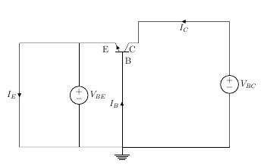

Fig 3: Input Characteristics Circuit

**Output Characteristics:** The most important characteristic of the BJT is the plot of the collector current, $I_{C}$, versus the collector-emitter voltage, $v_{CB}$, for various values of the base current, $I_{E},$ as shown on the circuit on the right.

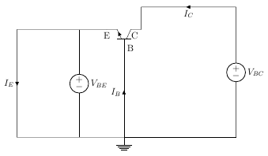

Fig 4: Output Characteristics Circuit

**Circuit Diagram:**

1. Input Characteristics:

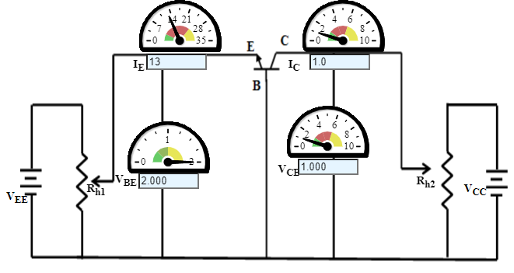

1. Output Characteristics:

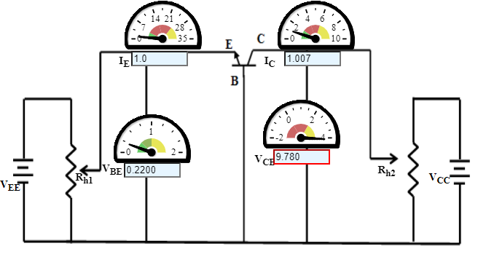

**Graph:**

1. Input Characteristics:

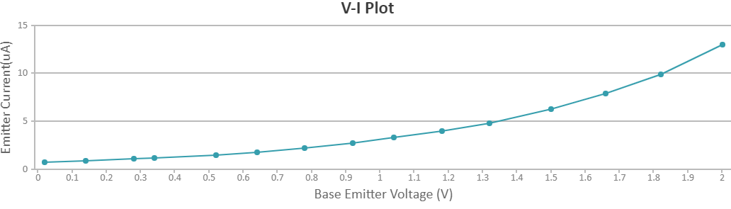

1. Output Characteristics:

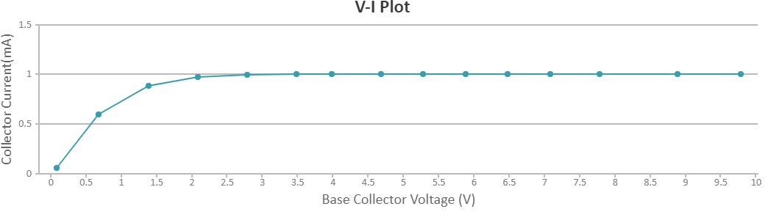

**Observations:**

1. Input Characteristics:

Base Collector Voltage, VCB=1.000 Volts

|  |  |  |
| --- | --- | --- |
| S.No. | Base Emitter Voltage (V) | Emitter Current (mA) |
| 1 | 0.02000 | 0.76 |
| 2 | 0.1400 | 0.90 |
| 3 | 0.2800 | 1.1 |
| 4 | 0.3400 | 1.2 |
| 5 | 0.5200 | 1.5 |
| 6 | 0.6400 | 1.8 |
| 7 | 0.7800 | 2.2 |
| 8 | 0.9200 | 2.7 |
| 9 | 1.040 | 3.3 |
| 10 | 1.180 | 4.0 |
| 11 | 1.320 | 4.8 |
| 12 | 1.500 | 6.3 |
| 13 | 1.660 | 7.9 |
| 14 | 1.820 | 9.9 |
| 15 | 2.000 | 1.3 |

1. Output Characteristics:

Emitter Current, IE=1.0 mA

|  |  |  |
| --- | --- | --- |
| S.No. | Base Collector Voltage (V) | Collector Current (mA) |
| 1 | 0.08000 | 0.06043 |
| 2 | 0.6800 | 0.5959 |
| 3 | 1.380 | 0.8875 |
| 4 | 2.080 | 0.9764 |
| 5 | 2.780 | 0.9997 |
| 6 | 3.480 | 1.005 |
| 7 | 3.980 | 1.007 |
| 8 | 4.680 | 1.007 |
| 9 | 5.280 | 1.007 |
| 10 | 5.880 | 1.007 |
| 11 | 6.480 | 1.007 |
| 12 | 7.080 | 1.007 |
| 13 | 7.780 | 1.007 |
| 14 | 8.880 | 1.007 |
| 15 | 9.780 | 1.007 |

**Result and Conclusion:** The input and output characteristics of Common Base configuration of n-p-n transistor has obtained and plotted successfully.